Portland Public Schools

**Application for District Sponsorship of a Public Charter School**

**General Instructions for 2025**

More specific instructions are in the application.

|  |  |
| --- | --- |
| **Application Due Date and Time** | **The District must receive the completed application ON Tuesday, July 15, 2025, by 5:00 p.m. local time. Applicant MUST have submitted a letter of intent to apply on or before May 1, 2025 in order to be eligible to apply on July 15, 2025. Please submit a letter of intent by email.** |
| **Numbers, Types of Application Copies Required** | Deliver two paper copies and an electronic copy of the signed application to the PPS Charter Schools Office. |
| **How and Where to Deliver the Completed, Signed Application** | The two paper copies of the signed application may be delivered by mail to:  Sunita Sandoz  Charter Schools Director  Portland Public Schools  P.O. Box 3107  Portland, Oregon 97208-3107  or in person to:  Sunita Sandoz  Charter Schools Director  Portland Public Schools  501 N. Dixon,  Portland, Oregon 97227  Note: The District must receive the paper copies on Tuesday, July 15, 2025, by 5:00 p.m. local time. A July 15, 2025, postmark will not qualify as delivery.  Send the electronic copy as an email attachment to Sunita Sandoz at [ssandoz@pps.net](mailto:ssandoz@pps.net), and submit on a flash drive.  Ms. Sandoz will confirm delivery of the application copies by email to the applicant. |
| **Application Format** | **The 2025 application cycle is ONLY for charter schools that do NOT serve high school grades 9-12. Examples of applications that will be accepted in 2025 include K-5s, K-8s, 6-8s. Applications for charter schools that do include a high school component will be accepted in July, 2026 (9-12, 6-12, or K-12, etc.)**  Except for budget documents, tables, and exhibits, each page must be typed and formatted for:   * 8.5” x 11” paper size, * one-inch margins, * no smaller than an 11-point font, and * no less than standard single spacing.   The application must be within the 55-page limitation stated in the application. Budget documents and all exhibits must be submitted in the format provided by the District. Provide your answers on the application form in the order provided and use all tables, spreadsheets, and other templates provided. |
| **Complete Application** | To be complete, the application must address each item in each section of the application, including required tables and exhibits. You may verify this for yourself using the Completeness Checklist. Within 30 days from July 15, 2025, the Charter Schools Director will notify the applicant if the application is complete. If the application is not complete, the Applicant will have 30 days to resubmit a revised application. Please see the flowchart below for a detailed description of timelines. |

**Application Process Flow Chart**

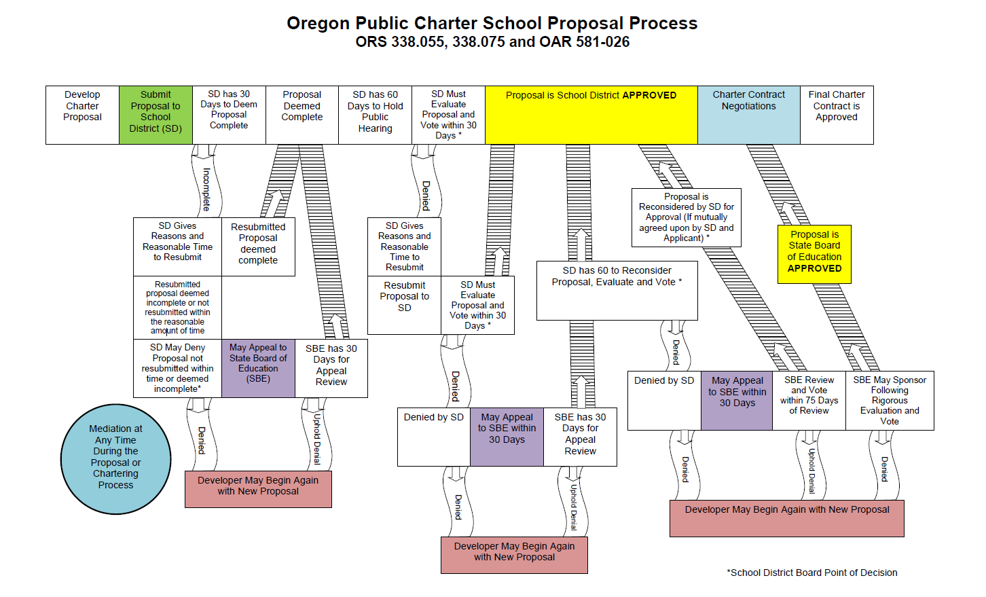

**Oregon Public Charter School Proposal Process   
ORS 338.055, 338.075 and OAR 581-026**

Oregon Department of Education – Charter Schools 2018 (provided by the ODE)

1. Developer submits charter school proposal to school district.

a. District has 30 days to deem proposal complete:

i. District deems proposal complete. Move to step 3.

ii. District deems proposal incomplete, gives reasons and reasonable time to resubmit.

1. No proposal is resubmitted. Developer may begin again with a new proposal. Process complete.

2. Resubmitted proposal is deemed complete. Move to step 3.

3. Resubmitted proposal is deemed incomplete or not resubmitted within the reasonable amount of time.

a. District may deny proposal not resubmitted within time or deemed incomplete. Process complete or move to step 2.

2. Developer may appeal denial to the State Board of Education.

a. State Board has 30 days to review the appeal to:

i. Uphold denial.

1. Developer may begin again with a new proposal. Process complete.

ii. Deem proposal as complete and remand to the district for evaluation. Move to step 3.

3. District has 60 days to hold a public hearing regarding a complete proposal. Move to step 4.

4. District must evaluate and vote on the proposal within 30 days of the public hearing.

a. District votes to approve the proposal. Move to step 7.

b. District denies proposal, gives reasons and a reasonable time to resubmit.

i. No proposal is resubmitted. Developer may begin again with a new proposal. Process Complete.

ii. Resubmitted proposal is received within reasonable time. District has 30 days to evaluate and vote on the proposal.

1. District votes to approve the proposal. Move to step 7.

2. District denies proposal. Process complete or move to step 5.

5. Developer may appeal denial to the State Board of Education.

a. State Board has 30 days to review the appeal to:

i. Uphold denial.

1. Developer may begin again with a new proposal. Process complete.

ii. Remand the proposal to the district for evaluation. District has 60 days to reconsider, evaluate and vote.

1. District votes to approve the reconsidered proposal. Move to step 7.

2. District denies reconsidered proposal. Process complete or move to step 6.

6. Developer may appeal denial to the State Board of Education within 30 days.

a. State Board has 75 days to review the appeal to:

i. Uphold denial.

1. Developer may begin again with a new proposal. Process complete.

ii. Remand the proposal to the district for reconsideration if mutually agreed upon by the district and the developer.

1. District votes to approve the reconsidered proposal. Move to step 7.

iii. Consider approving the proposal:

1. State Board votes to approve the proposal. Move to step 7.

2. State Board denies the proposal. Developer may begin again with a new proposal. Process Complete.

7. Proposal has been approved by the district or the State Board. Contract negotiations begin and a charter contract is executed.

**Application for a Public Charter School that does NOT include a High School Component**

By signing this application, I/we acknowledge that the District must receive two paper copies and one electronic copy of this signed application **on Tuesday, July 15, 2025, by 5:00 p.m. local time**. I/we must provide all required information using the provided forms, tables, and spreadsheets. The narrative application must not exceed 55 pages, excluding this page, the required tables, exhibits, budget forms, reference letters, and resumes. Other supporting materials may be referenced in the application. However, the District will not accept materials that are not part of this application unless requested by the Charter Schools Director. I/we have received, read, and understand the General Instructions, Application, Proposal Process Flowchart, Completeness Checklist, and Review Criteria.

I/we understand that within 30 days from July 15, 2025, the Charter Schools Director will notify me/us if this application is complete. If the application is complete, the review process continues. If the application is not complete, the applicant will have 30 days to revise and resubmit the application. The applicant will be allowed ONE opportunity to revise and resubmit an incomplete proposal.

**Name of Applicant (Organization/Individual):______________________________________**

**Name of Proposed Charter School: ______________________________________**

**Name of person(s) authorized to represent the proposal:**

**A. __________________________________ Title: ____________________________________**

**B. __________________________________ Title: ___________________________________**

**C. __________________________________ Title: ____________________________________**

**D. __________________________________ Title: ____________________________________**

**Permanent address of applicant:**

**Street: _____________________________________**

**City: __________________________Zip________**

**Telephone: _____________________________________**

**Fax: _____________________________________**

**Signature of Person(s) Submitting Proposal: ______________________________________**

**______________________________________**

**______________________________________**

**Date: _____________**

**Application for a Public Charter School that does NOT include a High School Component (continued)**

The Charter Schools Director must receive the completed paper and electronic application documents on Tuesday, July 15, 2025, by 5:00 p.m. local time. A July 15 postmark will not qualify.

The application provides the information required by ORS 338.045, ORS 338.055, OAR 581-026-0050, and District Policy 6.70.010-P. Respond to the questions in the application in the order presented. All pages must be in the format specified in the General Instructions.

In the past, successful charter school applicants have demonstrated the ability to establish and implement charter school proposals by providing evidence of a well-developed mission; a strong educational program; supports for learning; accountability measures; a sound financial, business, and organizational plan; and verifiable evidence of sufficient supports for the proposal from educators, families, and the community.

**Portland Public Schools is particularly interested in charter school applications that focus on closing achievement and opportunity gaps, and educating an ethnically, racially, and socioeconomically diverse group of students with culturally competent and culturally sustainable curriculum and pedagogy.**

**Please initial all items and sign below. Submit this page with your application.**

I/we have read, understood, acknowledge, and agree to the following:

_____ The narrative application (excluding tables, budget documents, exhibits, and instructions) is no longer than 55 pages in length. I/we have used standard one-inch margins and no smaller than 11-point font.

_____ I/we submitted a letter of intent to apply for charter school status to the Charter Schools Program Director on or before May 1, 2025.

_____ I/we have used the provided binder and dividers to organize the application form, tables, budget documents, and other templates to complete and submit the application.

_____ I/we have organized the paper application in the order it appears on the application form.

_____ I/we have provided two paper copies and one electronic copy to the Charter Schools Program Director.

_____ I/we understand that if the application is found to be incomplete, I/we have ONE opportunity to revise and resubmit the application. Resubmission of the application must be within 30 days of notification of incompleteness.

______ I/we understand that I/we may be asked for additional information relevant to the application at any time during the application process. I/we understand that I/we may not submit additional information after the July 15, 2025 due date unless specifically requested to do so by the Charter Schools Program Director.

_____ I/we have received the following documents:

_____ Application for District Sponsorship of a Public Charter School (including instructions, timelines, exhibit templates, budget documents, binder and dividers.)

_____ Completeness Checklist

_____ Application Review Criteria and Rubric

Signature:__________________________ Date: ___________

**Section 1: General Information**

1. State the projected enrollment to be maintained and the ages or grades to be served when the school is fully enrolled. **(For the 2025** **application year, ONLY applications that do NOT include a high school component will be considered.)**
2. Describe the target population of students the public charter school will be designed to serve.
3. State the legal address, facilities and physical location of the public charter school, if known. If not known, state the region within Portland Public Schools District boundaries the charter applicant intends to locate the charter school.
4. Describe the rationale for selecting the location and targeting the specified population.
5. Describe how the location and facilities will accommodate the school’s operations and the targeted student population, including students or staff with disabilities, and meet state and district standards for schools.
6. Describe the plan to provide for any future space needs.
7. Provide a description of proposed admission policies and application procedures.
8. Include a description of the proposed lottery procedures and how they will comply with statutory requirements (ORS 338.125).
9. Assure the school’s compliance with all statutes and rules that shall apply to the public charter school, all applicable district policies and administrative directives and procedures, and its cooperation with district staff at all levels.
10. State the date upon which the public charter school would begin operating.
11. State the requested term of the proposed charter.

**EXHIBIT I**

**PROJECTED CHARTER SCHOOL ENROLLMENTS and STAFFING RATIOS**

**NAME of PROPOSED CHARTER SCHOOL:**

This exhibit is to determine the proposed charter school’s projected total enrollments and staffing ratios. Enter the projected enrollment and staffing ratios at each grade range. If a grade range does not apply, enter NA. Complete next page as well. Use the data when appropriate to respond to a section of the charter application. If the school will not be fully enrolled by year 6, add rows to indicate projected enrollment and staffing ratios until fully enrolled.

|  |  |  |  |  |  |  |  |  |  |  |  |
| --- | --- | --- | --- | --- | --- | --- | --- | --- | --- | --- | --- |
|  | **Total Enrollment Grades K-5** | **Total Enrollment Grades 6-8** | **Total School Enrollment** | **Total # Teachers** | **Total #**  **Staff (includes teachers)** | **Student/**  **Teacher Ratio Grades K-5** | **Student/**  **Teacher Ratio Grades 6-8** | **Total Student/**  **Teacher**  **Ratio** | **Student/**  **Staff Ratio Grades K-5** | **Student/**  **Staff Ratio Grades 6-8** | **Total Student/**  **Staff**  **Ratio** |
| Year 1 |  |  |  |  |  |  |  |  |  |  |  |
| Year 2 |  |  |  |  |  |  |  |  |  |  |  |
| Year 3 |  |  |  |  |  |  |  |  |  |  |  |
| Year  4 |  |  |  |  |  |  |  |  |  |  |  |
| Year  5 |  |  |  |  |  |  |  |  |  |  |  |
| Year  6 |  |  |  |  |  |  |  |  |  |  |  |

**EXHIBIT I (CONTINUED)**

**PROJECTED CHARTER SCHOOL ENROLLMENTS and STAFFING RATIOS**

In the space below, describe the methods used to collect the data for Exhibit I.

**EXHIBIT II**

**CALENDAR and INSTRUCTIONAL TIME**

1. Provide the proposed school calendar for the public charter school, including the length of the school day and school year.
2. Include how the proposed calendar and hours of instruction meet or exceed the minimum annual hours of instruction by grade levels required by Oregon Administrative Rule 581-022-2320, Required Instructional Time.

**Section 2: Demand for the Program**

*ORS 338.055(3)(a): The demonstrated, sustainable support for the public charter school by teachers, parents, students and other community members.*

1. Not including individuals involved in the development of the charter school proposal, explain how educators, families, and community members demonstrated and continue to demonstrate sustainable levels of support for the proposed charter school.
2. Describe the manner in which community groups may be involved in the planning and development process of the public charter school.
3. Consider the following goal from the PPS Racial Educational Equity Policy [2.10.010-P](https://www.pps.net/cms/lib/OR01913224/Centricity/Domain/4814/2.10.010-P.pdf):

“The District shall welcome and empower families, including underrepresented families of color (including those whose first language may not be English) as essential partners in their student’s education, school planning and District decision-making. The District shall create welcoming environments that reflect and support the racial and ethnic diversity of the student population and community.  In addition, the District will include other partners who have demonstrated culturally-specific expertise -- including government agencies, non-profit organizations, businesses, and the community in general -- in meeting our educational outcomes.”

1. Explain how the charter school, acting in partnership with the District, would help meet this goal.
2. Explain how the groups described in the goal support the development of the proposed charter school.
3. Explain how the groups described in the goal above have been engaged in the development of this proposal to help mitigate negative impact on underrepresented families of color.

**EXHIBIT III**

**POTENTIAL CHARTER SCHOOL STUDENTS ATTENDING PPS and OTHER SCHOOLS**

**NAME of PROPOSED CHARTER SCHOOL:**

This exhibit is to determine the number (N) of the proposed charter school’s potential students, who have documented interest in attending the charter school, who currently attend Portland Public Schools, private schools, other districts, or who are homeschooled. **Enter each school name alphabetically in the appropriate columns. Enter the number (N) of potential charter school students currently attending each school. If a grade range does not apply, enter NA in the first school name cell and enter zero (0) in the N cell.** Add rows if necessary. Complete the next page. Use the data when appropriate to respond to a section of the charter application.

|  |  |  |  |  |  |  |  |  |  |
| --- | --- | --- | --- | --- | --- | --- | --- | --- | --- |
| **PPS Schools that include Grades K-8** | **N** | **PPS High Schools** | **N** | **Other Districts:**  **Public Schools K-12** | **N** | **Resident Districts of Home-Schooled Students in Grades K-12 (include PPS)** | **N** | **Resident Districts of Privately Schooled Students in Grades K-12 (include PPS)** | **N** |
|  |  |  |  |  |  |  |  |  |  |
|  |  |  |  |  |  |  |  |  |  |
|  |  |  |  |  |  |  |  |  |  |
|  |  |  |  |  |  |  |  |  |  |
|  |  |  |  |  |  |  |  |  |  |
|  |  |  |  |  |  |  |  |  |  |
|  |  |  |  |  |  |  |  |  |  |
|  |  |  |  |  |  |  |  |  |  |
|  |  |  |  |  |  |  |  |  |  |
|  |  |  |  |  |  |  |  |  |  |
|  |  |  |  |  |  |  |  |  |  |
|  |  |  |  |  |  |  |  |  |  |
|  |  |  |  |  |  |  |  |  |  |
|  |  |  |  |  |  |  |  |  |  |
|  |  |  |  |  |  |  |  |  |  |
|  |  |  |  |  |  |  |  |  |  |
|  |  |  |  |  |  |  |  |  |  |
|  |  |  |  |  |  |  |  |  |  |
|  |  |  |  |  |  |  |  |  |  |
|  |  |  |  |  |  |  |  |  |  |
| **TOTAL** |  | **TOTAL** |  | **TOTAL** |  | **TOTAL** |  | **TOTAL** |  |

**EXHIBIT III (CONTINUED)**

**POTENTIAL CHARTER SCHOOL STUDENTS ATTENDING PPS and OTHER SCHOOLS**

1. Describe the methods used to collect the data for Exhibit III. Attach sample/template copies of surveys or other materials used to collect the data.
2. Explain how the data from Exhibit III provides quantifiable data demonstrating sufficient demand for the proposed charter school from teachers, parents, students, and other community members.

**EXHIBIT IV**

**PARENT/FAMILY SURVEYS**

1. Provide completed parent/family surveys. Evidence of parent and student support must represent students who will be in the grade levels served during the proposed term of the charter. Parent/family surveys must include at minimum:
   1. the number of potential students in each household;
   2. where the student(s) attend(s) school currently;
   3. the student’s current grade.

**EXHIBIT V**

**SUPPORT for the PROPOSED CHARTER SCHOOL by EDUCATORS and COMMUNITY MEMBERS**

**NAME of PROPOSED CHARTER SCHOOL:**

This exhibit is to identify the individuals involved in the development and operation of the proposed charter school. List individuals and/or organizations. Describe their specific commitments to the development and operation of the school. Describe any contracts or other agreements made or to be made with an individual or group. Use the data when appropriate to respond to a section of the charter application.

|  |  |  |  |
| --- | --- | --- | --- |
| **Individuals and Organizations Involved in the Development and/or Operation of the Proposed School** | **The Individual’s or Organization’s Experience and Qualifications to Assist in the Development or Operation of the Proposed Charter School in One or More of These Areas: Curriculum, Instruction, Assessment, Budget, Equity, or Operations** | **The Services Each Individual or Organization Will Provide for the Development or Operation of the Proposed Charter School** | **Contractual or Other Agreements Made or to be Made With the Individual or Organization** |
|  |  |  |  |
|  |  |  |  |
|  |  |  |  |
|  |  |  |  |
|  |  |  |  |
|  |  |  |  |
|  |  |  |  |
|  |  |  |  |
|  |  |  |  |
|  |  |  |  |
|  |  |  |  |
|  |  |  |  |
|  |  |  |  |
|  |  |  |  |
|  |  |  |  |

**EXHIBIT V (CONTINUED)**

**SUPPORT for the PROPOSED CHARTER SCHOOL by EDUCATORS and COMMUNITY MEMBERS**

1. Describe the methods used to collect the data for Exhibit V.
2. Attach copies of materials used to collect information from organizations or individuals.
3. Attach a resume for each Developer (founder) and each individual listed in Exhibit V.

**EXHIBIT VI**

**LETTERS of REFERENCE**

Attach at least three current letters of reference for each person and/or organization listed in Exhibit V from people familiar with their educational and organizational experience.

**Section 3: Financial and Organizational Plans**

*ORS 338.055(3)(b): The demonstrated financial stability of the public charter school, including the demonstrated ability of the school to have a sound financial management system that is in place at the time the school begins operating and that meets the requirements of ORS 338.095 (1).*

1. Describe the governance structure of the public charter school.
2. Explain how the board was established and how it supports:
   1. the school’s mission
   2. governance
   3. racial and cultural equity
   4. community outreach efforts
   5. fiscal stability
3. Describe the plan to train and recruit board members.
4. Explain how the directors’ roles are different from the school administrators’ roles.
5. Describe any advisory or other board committees and how they will relate to the school’s board and administration.
6. Describe the manner in which the program review and fiscal audit will be conducted.
7. Describe the plan for performance bonding and/or insuring the public charter school, including buildings and liabilities.

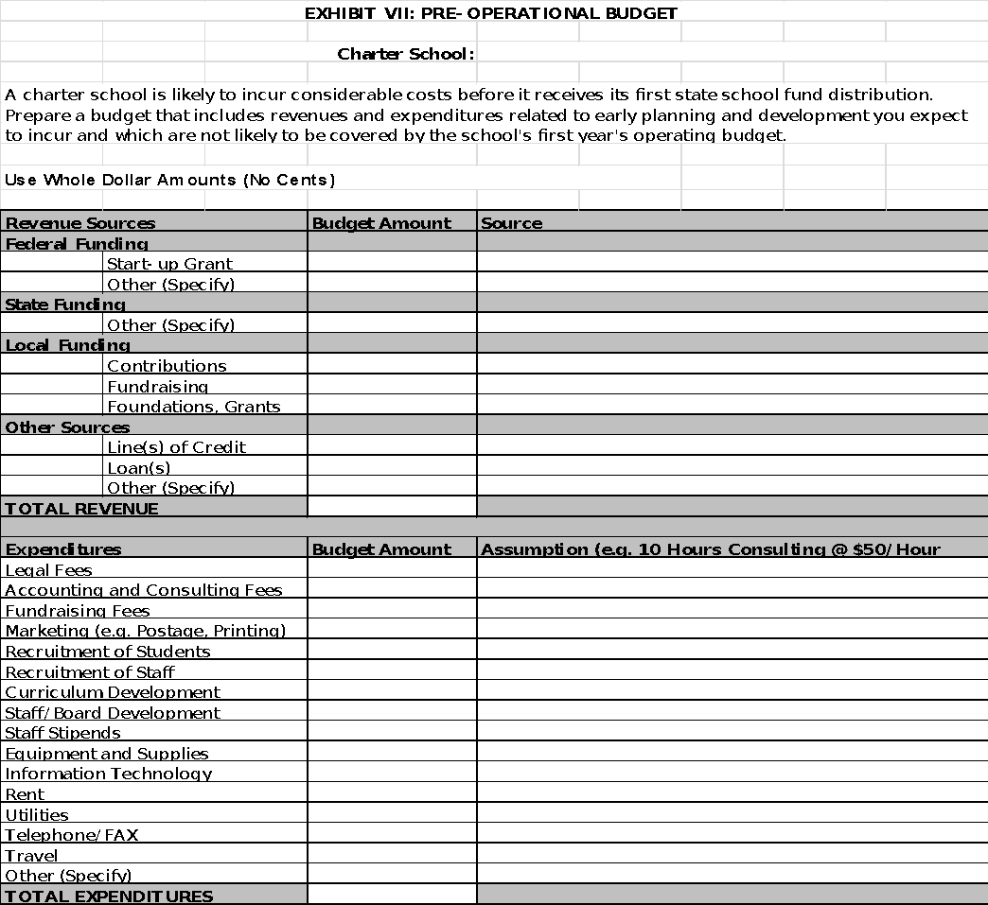

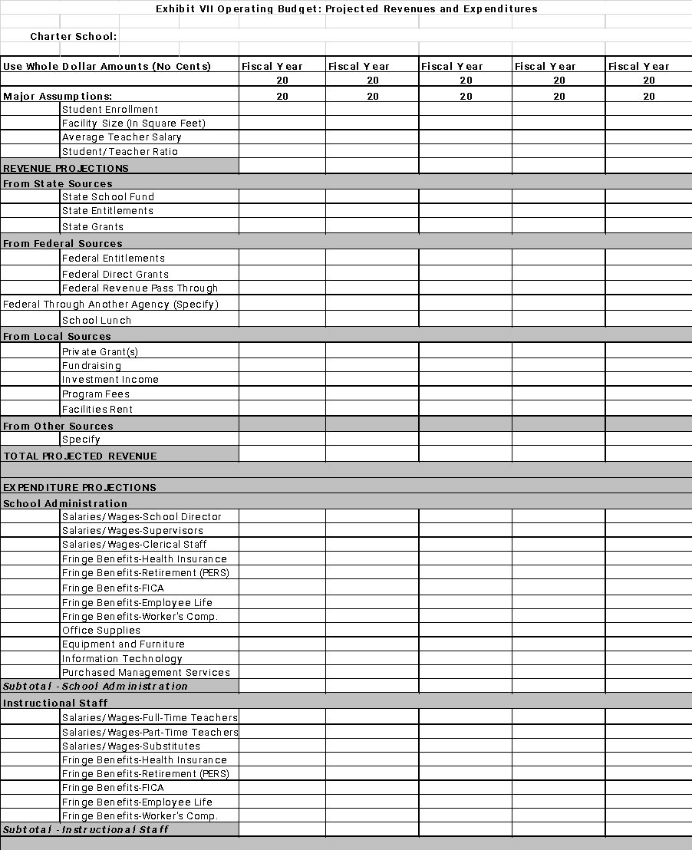

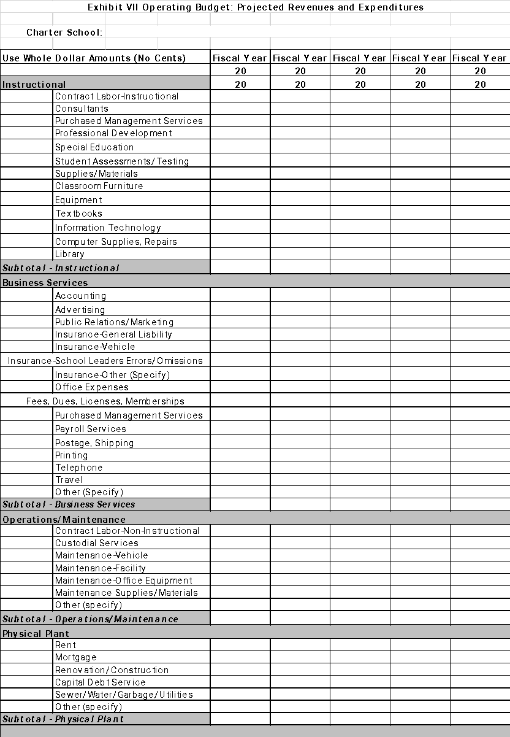

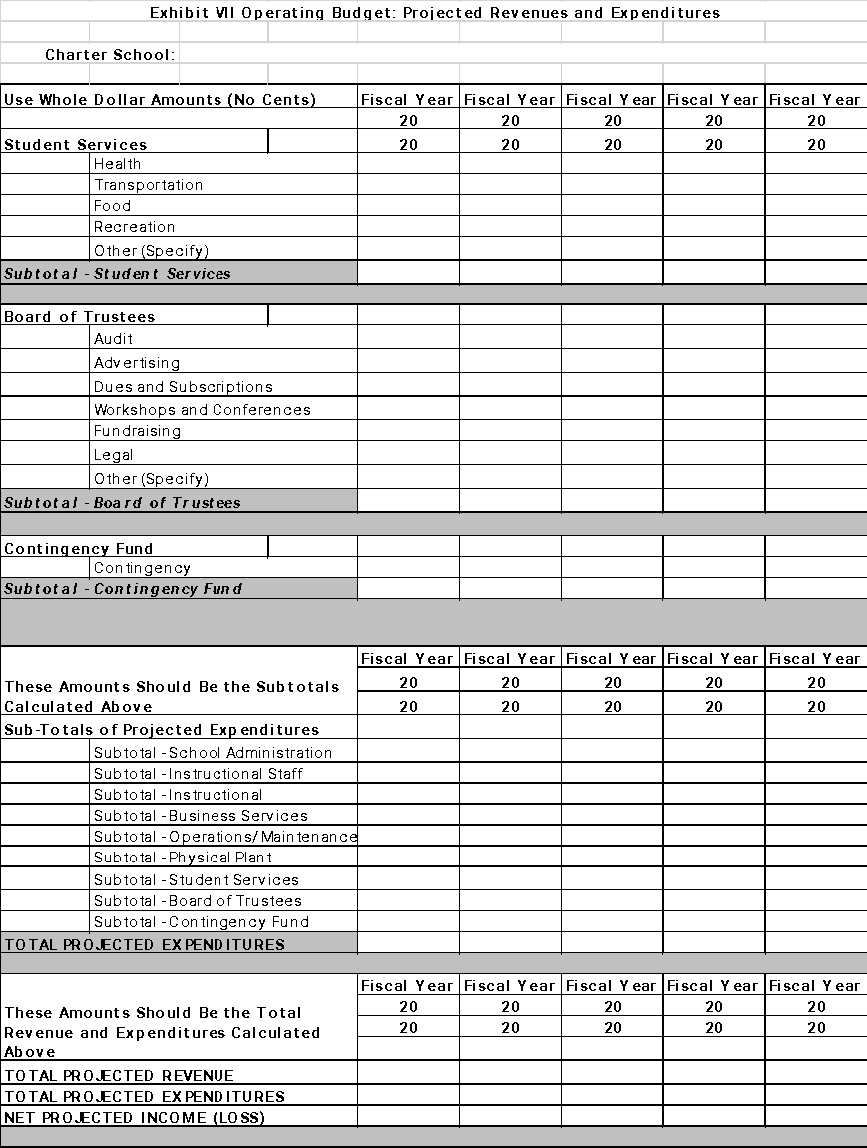

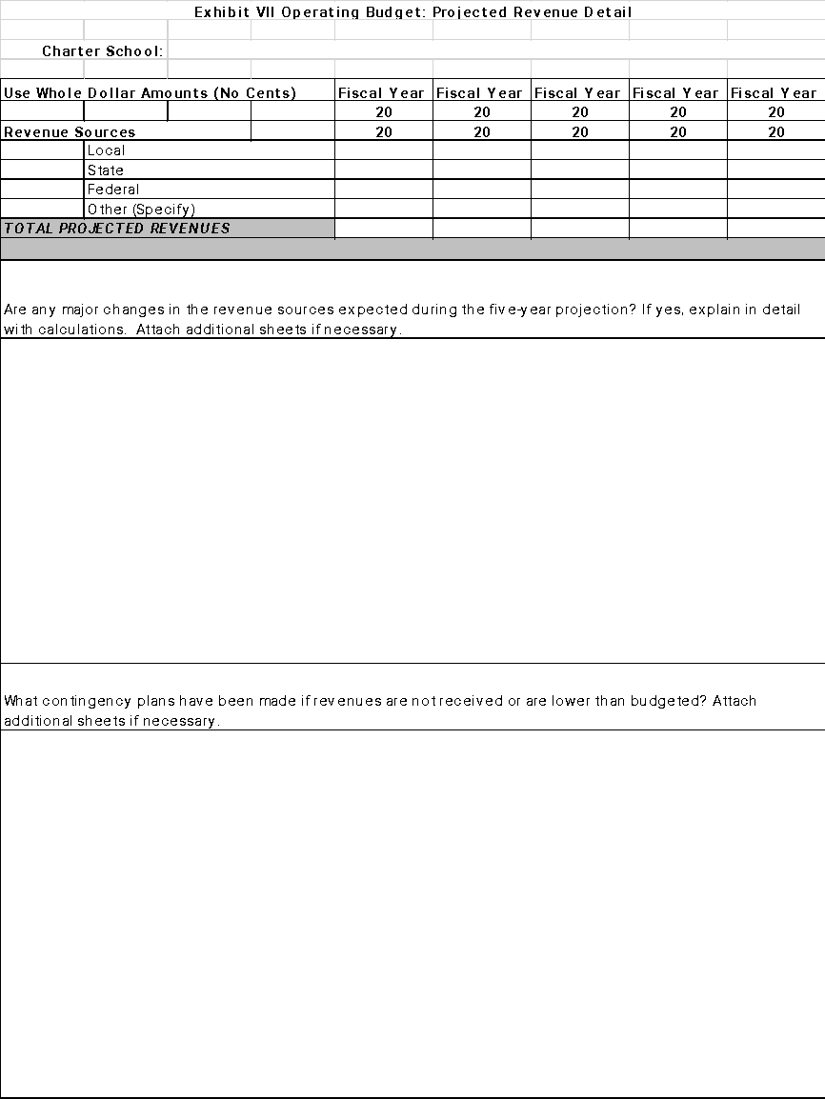

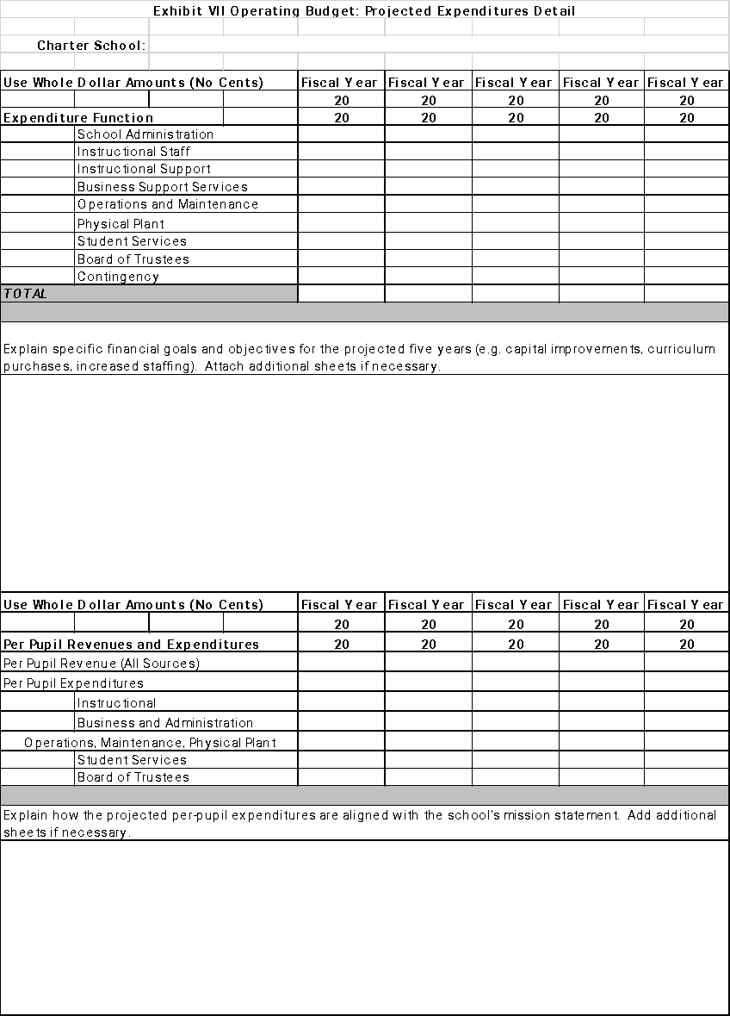

**EXHIBIT VIII**

**FINANCIAL PLAN**

Provide the financial plan for the public charter school. Include the following components:

1. Describe the financial management systems for the public charter school.
2. Describe how the financial management systems will meet the requirements of ORS 338.095(1).
3. Include a plan for having the financial management systems in place at the time the school begins operating. Include the role/title of the individual(s) that will be responsible for the implementation and operation of the financial management system.
4. Provide evidence that the systems and procedures in the proposed financial and business plan follow general accounting procedures.
5. Provide evidence that the proposed budget and financial plan for the public charter school are financially sound.

**EXHIBIT IX**

**BOARD of DIRECTORS for the PROPOSED CHARTER SCHOOL**

**NAME of PROPOSED CHARTER SCHOOL:**

This exhibit is to provide information about the board of directors of the proposed charter school. List directors alphabetically by last name. Describe each director’s qualifications. Give each director’s term of service. Add rows if necessary.

|  |  |  |  |  |
| --- | --- | --- | --- | --- |
| **Directors** | | **Each director’s qualifications to oversee educational programs, budgeting, finance, accountability, improvement planning, marketing, community outreach, and/or other areas important to the operation of a public charter school.** | **Term** | |
| **Last Name** | **First Name** | **Start**  **Year** | **End**  **Year** |
|  |  |  |  |  |
|  |  |  |  |  |
|  |  |  |  |  |
|  |  |  |  |  |
|  |  |  |  |  |
|  |  |  |  |  |
|  |  |  |  |  |
|  |  |  |  |  |
|  |  |  |  |  |
|  |  |  |  |  |
|  |  |  |  |  |
|  |  |  |  |  |
|  |  |  |  |  |
|  |  |  |  |  |
|  |  |  |  |  |
|  |  |  |  |  |
|  |  |  |  |  |

**EXHIBIT X**

**ACKNOWLEDGMENTS of UNDERSTANDING for GOVERNING BOARD**

**(to be signed by each Board member)**

**NAME of PROPOSED CHARTER SCHOOL:**

Oregon Revised Statute 338.045(3)(b) requires that “each member of a proposed public charter school governing body must provide an acknowledgment of understanding related to the standards of conduct and the liabilities of a director of a nonprofit organization, as those standards and liabilities are described in ORS chapter 65, if the public charter school is organized as required by ORS 338.035(2)(a)(B) and (C).”

**Please initial each item** to indicate you have reviewed related documents and understand the responsibilities you hold related to that item.

I acknowledge that I have reviewed the standards of conduct and the liabilities of a director of a nonprofit organization as those standards and liabilities are described in **Oregon Revised Statute (ORS) chapter 65** [click here](https://www.oregonlegislature.gov/bills_laws/ors/ors065.html).

I acknowledge that it is my responsibility to understand the standards of conduct and the liabilities of a director of a nonprofit organization as they relate to **holding a position on a public charter school governing board of directors** [clickhere](https://www.oregonlegislature.gov/bills_laws/ors/ors338.html)**. (**Charter School law ORS 338)

I acknowledge that I have reviewed a copy of **the articles of incorporation, bylaws and any policies or procedures** adopted by the nonprofit organization and will review all proposed governing documents in good faith prior to taking action.

I acknowledge that I am a public official bound to ethics laws in Oregon and I have reviewed the **Guide for Public Officials** published by the Oregon Government Ethics Commission [click here](https://www.oregon.gov/ogec/Documents/2010-10_PO_Guide_October_Final_Adopted.pdf).

I acknowledge that I am responsible for the comprehensive public education of students, public funds, the operation and oversight of a public school, and **conducting myself as a steward of such public assets**.

I acknowledge that I am one member of the governing board and **do not speak for or represent the board as a whole**.

I acknowledge that my actions and words as they relate to the governance and operation of the nonprofit organizations and public charter school are bound by **public meeting and public records laws** [click here](https://www.doj.state.or.us/oregon-department-of-justice/public-records/public-records-and-meetings-law/) and I will make everything available to the public as requested and allowed by law.

I acknowledge that I have reviewed the **Attorney General’s Public Records and Meetings Manuals** [click here](https://www.doj.state.or.us/oregon-department-of-justice/public-records/attorney-generals-public-records-and-meetings-manual/) published by the Oregon Department of Justice.

I acknowledge that it is my responsibility to **seek clarity and training as needed** to comply with nonprofit laws, ethics laws, charter school laws, and public school governance.

I acknowledge that it is my responsibility to **understand any changes to the law** which affect the standards of conduct, liabilities, or other responsibilities of a director of a nonprofit organization governing a public charter school in Oregon.

_______________________________________________ ____________________________________________ _________________

Print Name Signature Date

__________________________________

Position/Title on Nonprofit Board

**EXHIBIT X (continued)**

**List of Associated Statute, Guides, Manuals, and Other Documents for Charter School Board Directors**

The list of documents below are linked in the associated line items within the Acknowledgment of Understanding for your convenience, with the exception of the individual Charter School’s documents. Charter school Boards of Directors will need to provide those documents to any new Directors before requesting their signed Acknowledgments of Understanding.

Oregon Revised Statute **(ORS) Chapter 65** – Nonprofit Corporations

Oregon Revised Statute **(ORS) Chapter 338** – Public Charter Schools

The individual Charter School’s **Articles of Incorporation, Bylaws,** and any adopted **Policies and Procedures**

**Guide for Public Officials**, published by the Oregon Government Ethics Commission

Oregon Revised Statute **(ORS) Chapter 192.610-690** – Public Meeting and Public Records

Oregon **Public Records Manual** and **Public Meetings Manual**, published by the Oregon Department of Justice

**EXHIBIT XI**

**BYLAWS for the PROPOSED CHARTER SCHOOL**

Attach the bylaws.

**EXHIBIT XII**

**501(c)(3) STATUS**

Provide evidence that the school has qualified as an exempt organization under section 501(c)(3) of the Internal Revenue Code or that the school has applied for 501(c)(3) status.

**Section 4: Instructional Program**

*ORS 338.055(3)(c): The capability of the applicant, in terms of support and planning, to provide comprehensive instructional programs to students pursuant to an approved proposal.*

**For all questions: If replicating or using an existing program, provide data showing the program’s measurable effects on students’ academic achievement.**

1. Provide a description of the philosophy and mission of the public charter school.
2. Describe the curriculum of the public charter school and any distinctive learning or teaching techniques to be used.
3. Provide a description of the expected results of the curriculum, and the verified methods of measuring and reporting objective results that will show the growth of knowledge of students attending the public charter school and allow comparisons with other public schools.
4. Describe how the charter school will ensure that:   
   1. students meet growth targets,
   2. students meet subgroup growth targets,
   3. students meet all associated standards using current Oregon or federal accountability assessments in English/Language Arts, Mathematics, Writing, Science, and participation at grades 3-8 and 9-12, and attendance at all grades, where applicable.
5. Explain how the proposed curricula, methods, and materials are based on sound and effective models and/or approaches that will result in increased learning and achievement for all students.
6. Explain how the instructional program will support students of all races and ethnicities in meeting state content standards and benchmarks.
7. Explain how the proposed charter school will offer students comprehensive instruction (where applicable) in English Language Arts and Literacy, Science, Literacy in Science and Technical Subjects, Health Education, Arts, Mathematics, Educational Technology, Social Sciences, Literacy in History and Social Studies, World Language and Physical Education that meets the academic content standards adopted by the State Board of Education and meets other requirements adopted by the State Board of Education and the board of the public charter school.
8. Explain how the instructional program and curriculum will be designed to be culturally responsive, and to close achievement and opportunity gaps specific to race and poverty.
9. Explain how culturally relevant curriculum will be integrated into instruction at all levels.
10. Explain how this charter school proposal will help meet the following strategic objectives (where applicable).   
    **a. Enter first grade**: Ready to read – i.e., evidence of reading readiness by the school’s internal local performance measures.   
    **b. End of third grade:** Reading to learn – Students meet or exceed state benchmarks on ELA assessments.   
    **c. Middle years:** Ready for high school – i.e., student attendance is 90% or greater, students meet or exceed state benchmarks on ELA assessments, and students take and pass 8th grade algebra.   
    **d. Enter 10th grade:** On track to graduate: i.e., students complete 9th grade with 6 credits and not lower than a C grade in core subjects.  
    **e. 12th grade:** Graduating on time, ready for college and career.
11. Explain how this charter school proposal will minimize barriers to equal access and meet the needs of all students.
12. Explain how school performance data will allow comparisons with other public schools.
13. Explain how the instructional program will be differentiated or otherwise designed and implemented to meet the needs of students who are English Language Learners.
14. Explain how the instructional program will be differentiated or otherwise designed and implemented to meet the needs of students who are identified as Talented and Gifted.
15. Explain how the proposed charter school will address the Oregon legislature’s goals for charter schools in ORS 338.015:  
    * 1. Increase student learning and achievement.
      2. Increase choices of learning opportunities for students.
      3. Better meet individual students’ academic needs and interests.
      4. Build stronger working relationships among educators, parents, and other community members.
      5. Encourage the use of different and innovative learning methods that are not already provided by the district.
      6. Provide opportunities in small learning environments for flexibility and innovation, which may be applied, if proven effective, to other public schools.
      7. Create new professional opportunities for teachers.
      8. Establish additional forms of accountability for schools.
      9. Create innovative measurement tools.

**EXHIBIT XIII**

**PLAN of SERVICE for ENGLISH LANGUAGE LEARNERS**

Provide the ELL plan of service. (For guidance on English Language Learners at charter schools refer to the document, “Title III English Learners Program Guide 2019-20 – Oregon Department of Education”, pages 44 and 45, which can be found on the web by doing a search for the title of the document.)

**EXHIBIT XIV**

**504 PLAN**

Provide a plan for serving students that qualify under Section 504 of the Rehabilitation Act of 1973.

**EXHIBIT XV**

**CURRICULUM ALIGNMENT**

1. Show the alignments of the proposed curriculum and selected instructional materials to state-adopted content and performance standards at the grade levels to be served.
2. Explain the reason(s) for selection of the curriculum and instructional materials.

**Section 5: Educational Program for Academically Low-Achieving Students**

*ORS 338.055(3)(d): The capability of the applicant, in terms of support and planning, to specifically provide, pursuant to an approved proposal, comprehensive instructional programs to students identified by the applicant as academically low-achieving.*

1. Explain how the instructional program will be differentiated or otherwise designed and implemented to meet the needs of academically low-achieving students.
2. Describe the academic and other supports that will be available for students identified as academically low-achieving.

**Section 6: Additional Information Required by the District**

*ORS 338.055(3)(e): The adequacy of the information provided as required by ORS 338.045(2) and (3).*

Supports for Learning:

1. Describe the key employment requirements and qualifications for each staff position listed below. Include an explanation of how all teachers in core subjects will be qualified per requirements of Every Student Succeeds Act (ESSA).  
   1. Teachers. (Include qualifications for serving ELL, TAG, SpEd, etc.)
2. Teaching assistants.
3. Counselors.
4. Principals, directors, managers, and any other administrators. If any administrators have been identified or selected, provide their names and qualifications.
5. Support staff.
6. Others.
7. Explain how professional development needs will be identified and met for teachers and teaching staff.
8. Explain how professional development needs will be identified and met for administrators, support staff, and other staff.
9. Describe the plan for providing professional development specifically focused on racial equity and cultural responsiveness.
10. Explain the plan for providing child nutrition.
11. Explain the plan for providing transportation.
12. Explain the plan for providing co-curricular activities (if any).
13. Explain the plan for providing counseling (if any).

Performance and Accountability:

1. State the school’s specific annual student performance goals, as defined by the school. Explain how they are measurable for the proposed term of the charter.
2. State the school’s other specific goals. Explain how they are measurable. (Examples might include goals for parent involvement or staff training or professional development.)
3. Explain the school’s plan to use student and school performance data to inform and adjust its education program, supports for learning, and school improvement plan.
4. Describe how the charter school will provide its students equal access to participation in its programs or activities.

**EXHIBIT XVI**

**MARKETING and RECRUITMENT PLAN**

Provide the marketing and recruitment plan. Explain how the plan is:

a. Consistent with the school’s mission and goals.

* 1. Specifically designed to reach the school’s target population(s).
  2. Specifically designed to provide equity of access to all students.

**EXHIBIT XVII  
POLICIES**

Provide the following policies. You may use separate sheets for each or combine them in one document.

1. Student application and admission
2. Student withdrawal
3. Student promotion and retention
4. Standards for student behavior including:
   1. Discipline of students
   2. Discipline of students with disabilities
   3. Suspension of students
   4. Expulsion of students
5. Student attendance including:
   1. Excused absences
   2. Unexcused absences
   3. Vacations
   4. Tardiness
6. Homework
7. Bullying and harassment
8. Admission of students expelled from other schools and/or districts
9. Volunteers
10. Field trips
11. Staff and student technology and internet use
12. Emergency management and training (include a Healthy & Safe Schools Plan)
13. Allowable fees/fines to be charged to families
14. Every Student Belongs ([OAR 581-022-2312](https://secure.sos.state.or.us/oard/viewSingleRule.action?ruleVrsnRsn=282669))
15. Any other policies relevant to the mission or operation of the charter school

**Section 7: Value vs. Adverse Impact**

*ORS 338.055(3)(f): Whether the value of the public charter school is outweighed by any directly identifiable, significant and adverse impact on the quality of the public education of students residing in the school district in which the public charter school will be located.*

1. Explain why a public charter school was selected as the desired educational option for the grade levels and target population(s). Compare and contrast the charter school option to other options already available in the district.
2. Describe the proposed plan for the placement of public charter school teachers, other school employees and students of the public charter school upon termination or nonrenewal of the charter.
3. Describe how and where enrollment trends of district schools may be affected if the proposed charter school opens.

**Section 8: Special Education**

*ORS 338.055(3)(g): Whether there are arrangements for any necessary special education and related services for children with disabilities pursuant to ORS 338.165.*

1. Describe the arrangements for any necessary special education and related services provided pursuant to ORS 338.165 for children with disabilities who may attend the public charter school.
2. Explain how the instructional program will be differentiated or otherwise designed and implemented to meet the needs of special education students.

**Section 9: Prior History**

*ORS 338.055(3)(i): The prior history, if any, of the applicant in operating a public charter school or in providing educational services.*

1. Describe the prior history of any of the founding members of the charter school or any of the members of the charter school’s board in operating a public charter school.
2. Describe the prior history of any of the founding members of the charter school or any of the members of the charter school’s board in operating a 501(c)3 nonprofit organization.
3. Describe the prior history of any of the founding members of the charter school or any of the members of the charter school’s board in providing educational services.

**Section 10: Conversion of an Existing School to Charter School Status (if applicable)**

*ORS 338.055(3)(h): Whether there are alternative arrangements for students and for teachers and other school employees who choose not to attend or who choose not to be employed by the public charter school.*

1. In the case of an existing public school being converted to charter status:
   1. Describe the alternative arrangements for students who choose not to attend the public charter school and for teachers and other school employees who choose not to participate in the public charter school.
   2. Describe the relationship that will exist between the public charter school and its employees, including evidence that the terms and conditions of employment have been addressed with affected employees and their recognized representative, if any.

**Appendix: Virtual Charter Schools (ORS 338.120)**

An applicant proposing a virtual charter school must complete this section. As defined in ORS 338.005(5)(a-b), a “virtual charter school” is a public charter school that provides online courses, but does *not* include a public charter school that primarily serves students in a physical location. Please contact the PPS Charter Schools Office if you have questions about whether or not to complete this section. Any virtual charter school application submitted without this section completed will be considered incomplete and will be returned to the applicant.

This section must not exceed 20 pages. Therefore, the total application page limit for a virtual charter school application may not exceed 75 pages.

1. Describe the school’s plan for student academic achievement that addresses how the school will improve student learning and meet academic content standards required by ORS 329.045.
2. Describe the performance criteria that the school will use to measure the progress of the school in meeting the academic performance goals set by the school for its first five years of operation.
3. Describe the plan for implementing the proposed education program of the school by directly and significantly involving parents and guardians of students enrolled in the school and involving the professional employees of the school.
4. Provide a budget, business plan and governance plan for the operation of the school.
5. Describe the plan for monitoring and tracking student progress and attendance, including the plan for ensuring and documenting that students in the virtual public charter school receive the minimum instructional time for their grade.
6. Describe the plan for providing student assessments in a manner that ensures that an individual student is being assessed and that the assessment is valid.
7. Describe the plan to ensure that all school administration (superintendents, assistant superintendents, principals, assistant principals, etc.) are licensed to administer by Teachers Standards and Practices Commission (TSPC).
8. Describe the plan to ensure that at least 95% of the school’s instructional hours are taught by teachers licensed by TSPC and qualified as required by the Every Student Succeeds Act (ESSA).
9. Describe the school’s plan for maintaining student records and school records, including financial records, at a designated central office of operations that is located within the PPS school district. The plan should include how the school will maintain the confidentiality of these records.
10. Describe the plan to ensure equitable access to the education program of the school by ensuring that each student enrolled in the school:
    1. Has access to and use of computer and printer equipment as needed
    2. Is offered an internet service cost reimbursement arrangement under which the school reimburses the parent or guardian of the student, at a rate set by the school, for the costs of obtaining internet service at the minimum connection speed required to effectively access the education program provided by the school, or
    3. Has access to and use of computer and printer equipment and is offered internet service cost reimbursement.
11. Describe the plan to provide access to computer and printer equipment and the internet service cost reimbursement as described in item #10 above for students enrolled in the school who are from families that qualify as low-income.
12. Describe the plan to conduct school-sponsored optional educational events at least six times each school year at locations selected to provide convenient access to all students enrolled in the school who want to participate.
13. Describe the plan to conduct meetings at least twice a week between teachers and students enrolled in the school, either in person or through the use of conference calls or other technology.
14. Describe the plan to provide opportunities for face-to-face meetings between teachers and students enrolled in the school at least six times each school year.
15. Describe the plan to provide, at the time of a student’s enrollment, written notice to PPS and, if different, to the school district where the student is a resident. Please note that notification must be provided within 10 days of enrollment and must include: the name, age, and address of the student, and the name of the school in which the student was formerly enrolled.
16. Describe the plan to provide, at the time of the student’s withdrawal for a reason other than graduation from high school, written notice to PPS and, if different, to the school district where the student is a resident. Please note that notification must be provided within 10 days of withdrawal and must include: the name, age, and address of the student, the reason the student is no longer enrolled and, if applicable, the name of the school in which the student will enroll, if known to the virtual school, and the last day on which the student was enrolled at the virtual public charter school.
17. Provide an assurance that, upon request of PPS or a student’s resident school district, the virtual public charter school shall provide a student’s education records.
18. Provide an assurance that no member of the PPS school board shall be: an employee of the virtual public charter school, a member of the governing body of the virtual public charter school, or an employee or other representative of any third-party entity with which the virtual charter school has entered into a contract to provide educational services.
19. Provide an assurance that no person who is a member of the governing body of the virtual public charter school shall be an employee of a third-party entity with which the virtual public charter school has entered, or intends to enter, into a contract to provide educational services.
20. Provide an assurance that, if the virtual public charter school enters into a contract with a third-party entity to provide educational services for the virtual public charter school:
    1. No employee or member of the governing board of the third-party entity will attend an executive session of the PPS school board
    2. No employee of the virtual public charter school will promote the sale or benefits of private supplemental services or classes offered by the third-party entity
    3. The educational services provided by the third-party entity shall be consistent with Oregon state standards and requirements, and shall be changed on the same timelines that changes are imposed on the non virtual public charter schools in Oregon
    4. The virtual public charter school shall have on file the third-party entity’s budget for the provision of educational services, and that budget shall itemize:
       1. The salaries of supervisory and management personnel and consultants who are providing educational or related services for a public charter school in Oregon
       2. The annual operating expenses and profit margin of the third-party entity for providing educational services to a public charter school in Oregon
21. Provide an assurance that, upon request, PPS or a member of the public shall be given access to any of the documents described in this section that are public records, as provided by ORS 192.311 to 192.478.